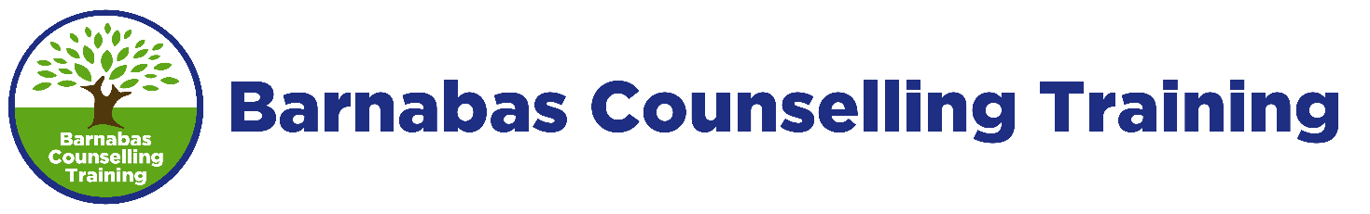Level 3 Certificate in Counselling Studies (CST-L3)
Course Programme

This course is usually run across one academic year comprising 12 x 7.5 hours teaching sessions, over 11 months. A typical day runs from 9.30am-6.00pm, with an hour for lunch; a total of 90 hours of guided learning hours is delivered across the programme.

This is a sample programme of the topics to be covered during the 12 sessions of the course. Individual course schedules will vary depending on the timing of the external assessment which takes place during a set week designated by CPCAB and may take place earlier than the final course session. The BCT course has been devised to ensure that each key element of the course criteria set by CPCAB is covered.

Tutors will make time during sessions to explain assessments and answer queries raised by students. A tutorial will be held with each student once in each half of the course.

Session 1
- Welcome and Introductions
- Course registration and introduction to course requirements
- Group Contract, Core Groups and Triplets
- Core concepts of Ethical Frameworks

Session 2
- Ethical Framework for Counselling
- Negotiating a User-Centred Contract
- Confidentiality in different work settings
- Stages of the counselling process
- The Therapeutic relationship
- Setting and maintaining boundaries
- Skills practice

Session 3
- The Counselling agency
- Client assessment
- Introduction to Humanistic and person-centred approaches
- Carl Rogers’ Person-Centred Theory
- Skills practice

Session 4
- Diversity
- Anti-discrimination
- Negotiating the working agreement for live skills work

Session 5
- Introduction to Supervision
- Live skills practice
- Peer group supervision

Session 6
- Introduction to the Psychodynamic Approach
- Introduction to Freud
- Live skills practice
- Peer group supervision

Session 7
- Introduction to CBT
- Live skills practice
- Peer group supervision

Session 8
- Evidence-based practice (research)
- Transpersonal approach to counselling
- Spirituality in counselling
- A Christian model for counselling
- The Bible in counselling

Session 9
- Introduction to Mental Health - common mental health problems
- Case Study Presentations

Session 10
- Introduction to Transactional Analysis
- Case Study Presentations

Session 11
- Mock CPCAB assessment and feedback
- Case Study Presentations
- Revision of 3 main approaches

Session 12
- Tutorials and portfolio submission
- Personal Review
- Endings

