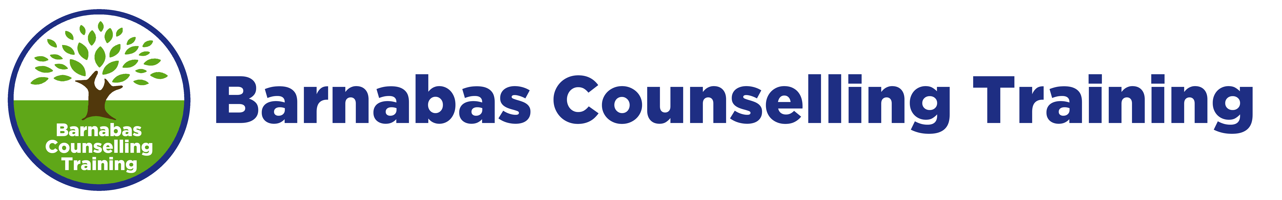
Confidential Tutor Referral Form
Please complete and return as soon as possible.

The following Student has applied to BCT to join the TC-L4 Level 4 Diploma in Therapeutic Counselling course.
Name:
Please complete the following to help us to assess his/her suitability. Please give answers that reflect your experience as the trainer on the course which they have just completed.

- Academic Ability
Please comment on the student’s ability to complete assignments, essays, journals etc to the required standard.

- Time-keeping, Punctuality and Responsibility
Please comment on the student’s attitude to time-keeping, including punctuality, meeting deadlines and payment of course fees.

- Social Skills
How did the student relate to other students and to the trainers on the course?

- Counselling Skills
How confident are you that the student has good basic counselling skills and would be able to hold clients well?

- Self-Awareness
Please comment on the student’s general self-awareness and personal development during the time you were their trainer. What indications do you have that he/she has the right personal qualities to become a professional counsellor, eg attitude, interpersonal skills, ability to handle conflict?

- Emotional Stability
The next level of training will place increased demands on the student. Please comment on their general emotional stability and ability to process course material which may be triggering.

- General Comments
Please add any further comments which you feel would be helpful to us.

TUTOR NAME

TUTOR SIGNATURE DATE

CONTACT TELEPHONE / EMAIL

Please return to: Barnabas Counselling Training, PO Box 752, Chichester, PO19 9QY
tel: 01243 543403; www.barnabastraining.com; email: info@barnabastraining.com

