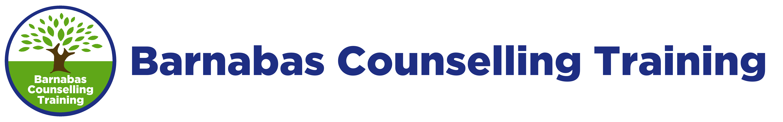
Confidential Reference Form
Name of Applicant:
Course Level and Title: Level 4 Diploma in Therapeutic Counselling
Course Length: 420 hours (over 2 years)

Thank you for supplying a reference for the above applicant.
Counselling training equips students to draw alongside others who are in a potentially vulnerable situation. We are concerned to ensure that students applying to start a course are sufficiently emotionally stable to undertake this training. We value your input into the selection process and would ask you to complete the following questions as fully as possible.
Please rank the applicant on a scale of 1(low) to 5 (high) for the following:
 | Low |  |  |  | High
Relates well to others | 1 | 2 | 3 | 4 | 5
Trustworthy, honest and reliable | 1 | 2 | 3 | 4 | 5
Evidence of listening skills | 1 | 2 | 3 | 4 | 5
Ability to manage conflict maturely | 1 | 2 | 3 | 4 | 5
Ability to handle stress | 1 | 2 | 3 | 4 | 5
Ability to hold confidences | 1 | 2 | 3 | 4 | 5
Commitment | 1 | 2 | 3 | 4 | 5
Motivation | 1 | 2 | 3 | 4 | 5
Do you feel this applicant will have sufficient support and personal resources as they begin this training?

Please add any further comments you feel it is important for us to know regarding this person’s suitability to undertake a counselling training course (continue overleaf if necessary)

Signed: Date:
Date and position:
Please return this completed form by post or email to:
Barnabas Counselling Training Ltd, PO Box 752, Chichester PO19 9QY, email: jallday@barnabastraining.com

